Dr. Simon Antony Roberts
10/466 Illawarra Rd
Marrickville South, NSW, 2204
Australien
simon@snails.email
+61-432-037-784

Dr. Alexander Shulgin
55 Shulgin Road
Lafayette, CA 94549
United States of America

27/12/17

To Dr. Alexander Shulgin,

You know over the years I have sent you normally a christmas card each year, but I forgot to this time, after you republished the 900 or so chemical descriptions my Artifical Intelligence system modelled I made once at Creative Software Solutions in Glenhaven, the industrial chemist that operates that business actually fired me over my perfectatron for psychoactive *.mol developer as it made a cost in making and testing them on a human effect API.

It was basically a program I wrote cause at creative software solution it is digital bubbles, they maintain and write something like a chemical ordering system for industries but with the resource, I wrote an AI that would get inputed *.mol and it would perfect them with options like:

- No nausia
- No scent
- Vaporisable
- Dissolvable in water
- None evaporating

So the AI would sit there and run computation changes to the *.mol for the option selected and then once they where all complete post them to alt.drugs and alt.psychedelic.drugs with all the instructions on making the *.mol on UseNet when it was all done I left it running over the weekend and by sunday had done the posts at the end all at one hit of all kinds of the stuff.
By wednesday I had lost my Job there in that historical corridor but did work there again in support next time around in history it came up basically due to the excessive charges on the *.mol human body testing API I was using to test the molecule changes to make sure they where all well and good and as the original with substancial changes. DIPT is an example of the perfect version of LSD25 the code DIPT like the other(s) is generated randomly.

Btw. I am writing this letter on just not long ago some MDMA that I took intravenously I had some meth around an hour or two before that so my belly is nice and walm, anyway, so I now have a Masters through RMIT in 2008 awarded for IT, Physics + Psychology making me now also a psychiatrist which is good I have been for a number of years just working in Open Source and community based projects but if you can I would like the text books which you will be able to access via the IT Department of RMIT printed through transform press as part of my masters I presented 13 text, and they are all in bundled with artwork and printing markers ready to go to the printer, my main one was an index similar to TiHKAL + PiHKAL in part story book but also an index layed out like the merck index for molecules to use in pharmacology.

I basically rewrote pharmacology as well as some texts on physics and so on I need all published and I was hoping you could pass this information on to your publisher Transform Press to take me in as alternate chemistry and science text books: 35% goes to medicine san`frontier as donation the rest we divey up. There is also digital media with the chemistry titles, there is multiple volumes in it in formats for LAMP Stacks etc. and so on that goes with the publication (some of them)!

I have two business registered you can find them on https://abr.business.gov.au called: Chronolabs & Undo Corporation is the two of them, I have only been operating out of the Chronolabs cooperative the Undo Corporation has basically been sitting in shelf since it conscreation so far for example in my github.com resourses this is the molecular compounding tool I wrote in PHP for XOOPS 2.5: https://github.com/Chronolabs-Cooperative/Compounds-Module-Xoops25.
So what about me, myself, my profile and what I like, well I have been living in Sydney most of my life and I am nearing 40 solar cycles on this set of my passport which the serial number I generate myself which is: M8747409 – DOB: 08/12/1978 (See Image Below); cause I am one of the founders of the internet, I was the person that put the design Vinton Gregory Cerf worked off through implementation by design as a small boy back in the 1980’s. I have lived through the early part of my life out of home age 17 and lived from warehouse to country doofimunies and community living as well as boarding houses, where I have been putting myself in that time of moving around through open university routed to rmit and doing it correspondence and so on.

I have since an early age been skilled and maintain current day trends in programming for nearly 30yrs testing and writing environments as well as business operations reporting documenting as well as new article topology. Since 2007 have been a member of xoops.org and now hold rank on the project of a module developer under the username, wishcraft my other alias is mynamesnot or if special characters are allowed ways|: is one I also have been known to use.

I tend to have never used Apple machintosh or Microsoft windows using open source operating systems in my home and work environments, as I don’t need any game intensive graphical environments as an occupational code junky! The OS I is using at the moment and tend too recommend and suggest to people is : Ubuntu – which you can get the ISO from http://releases.ubuntu.com to install what I am running Ubuntu 17.04 (32 + 64Bit Enviroments) it has a clean physicality and doesn’t drive pedometers unlike the above mentioned, it is a variegate of Debian Linux.

I married around 9yrs ago to a Greek Girl; Elpiniki Iosif (Image Below) and as we are part of the internet community her like me is quiet squeaky clean and clean living together, we only part take in narcotics once every week when my flatmate get paid Neil Watters and that really only cause we don’t drink alcohol in anyway, I view it like an infection motor mouth the earliest form of petroluem this alcohol and you get something like foot and mouth diease called motor mouth if you ever really even have it in your physicality and physical environmentals.
We have two cats which are resque pets the mother of the two, Meow Meow Twerp (MMT – See Photo Below) as well as one of her two daughters that were born before they where all given the snip: Vincent Mozzerella Twerp (VMT – See Photo Below) [the kittens went to Cat Protection Society – Enmore].

We living in government housing in Marrickville South, NSW, Australia, and have our financies controlled for some reason via my mother-in-law. So we live on both of us an allowance of $20.00 per day → for some reason my mother-in-law got Elpiniki online shopping habit confused for narcotics, we actually spend little of our money if any on this, part taking in whatever comes by our own place and home (see photos below x 3).

So well I will leave it about there I know with the amount of reading we all do a breifed tight letter is always a pleasure, I hope to hear some form of correspondence and for me email or twitter (@SimonXaies) is always the best way of reaching me!

Great kindness & regards,
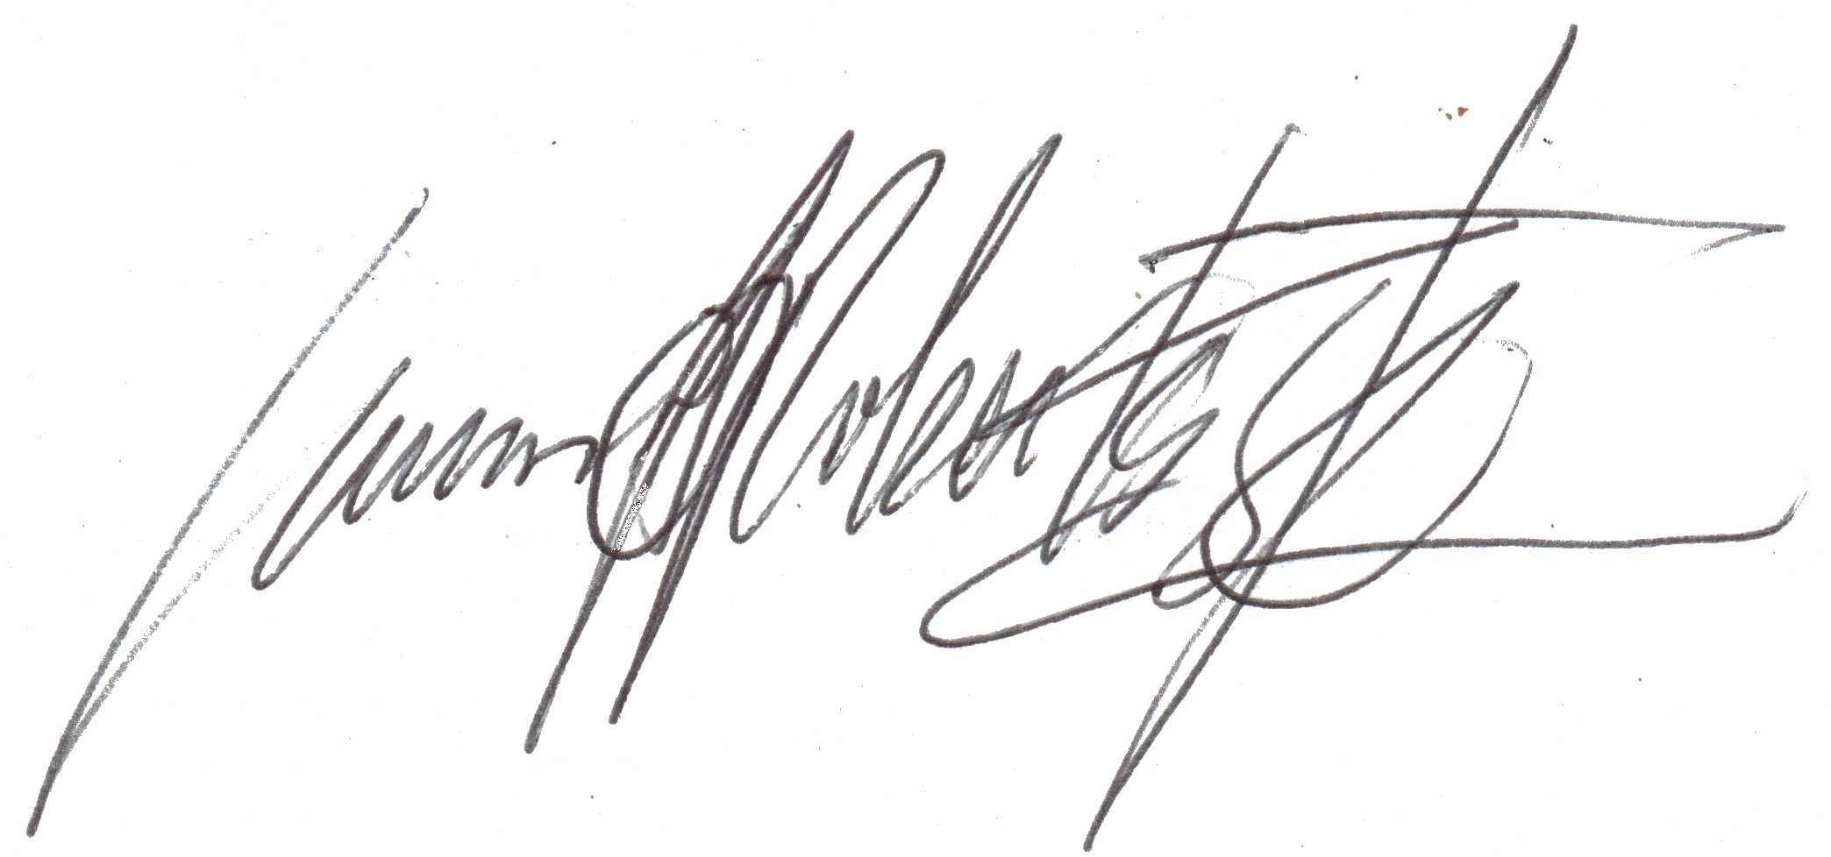

Dr. Simon A. Roberts
skype: conquebine@outlook.com
email: simon@snails.email
https://facebook.com/mynamesnot
https://twitter.com/SimonXaies

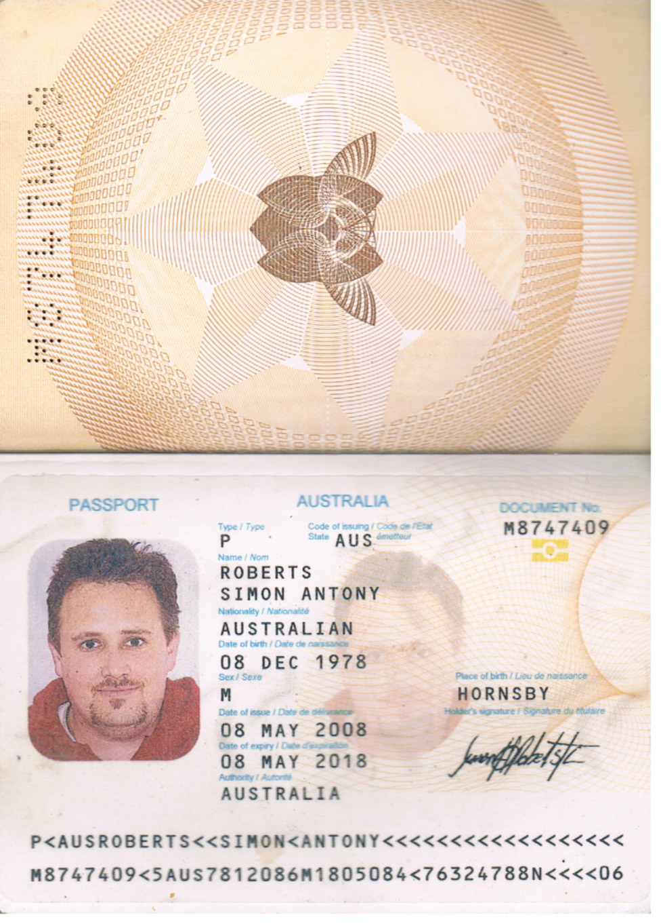
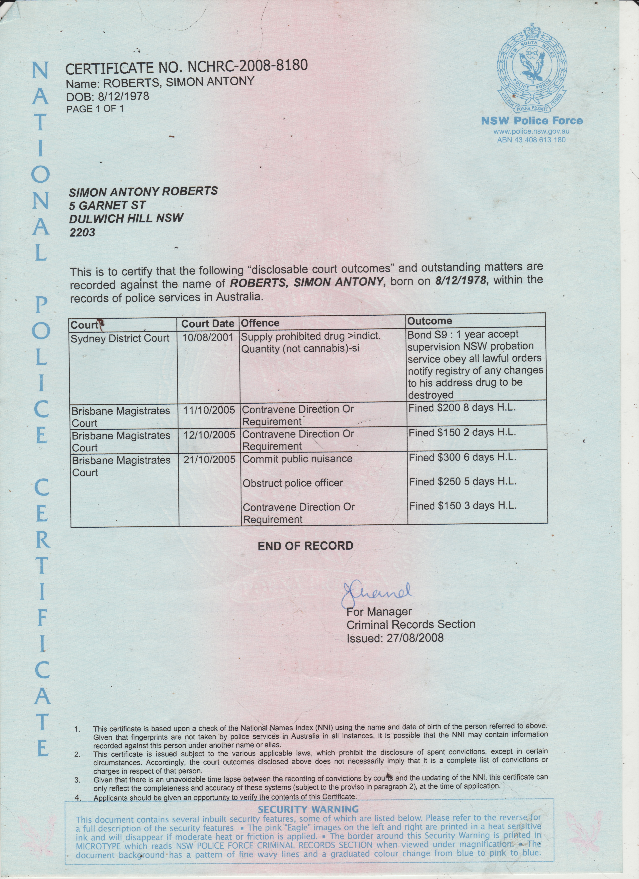
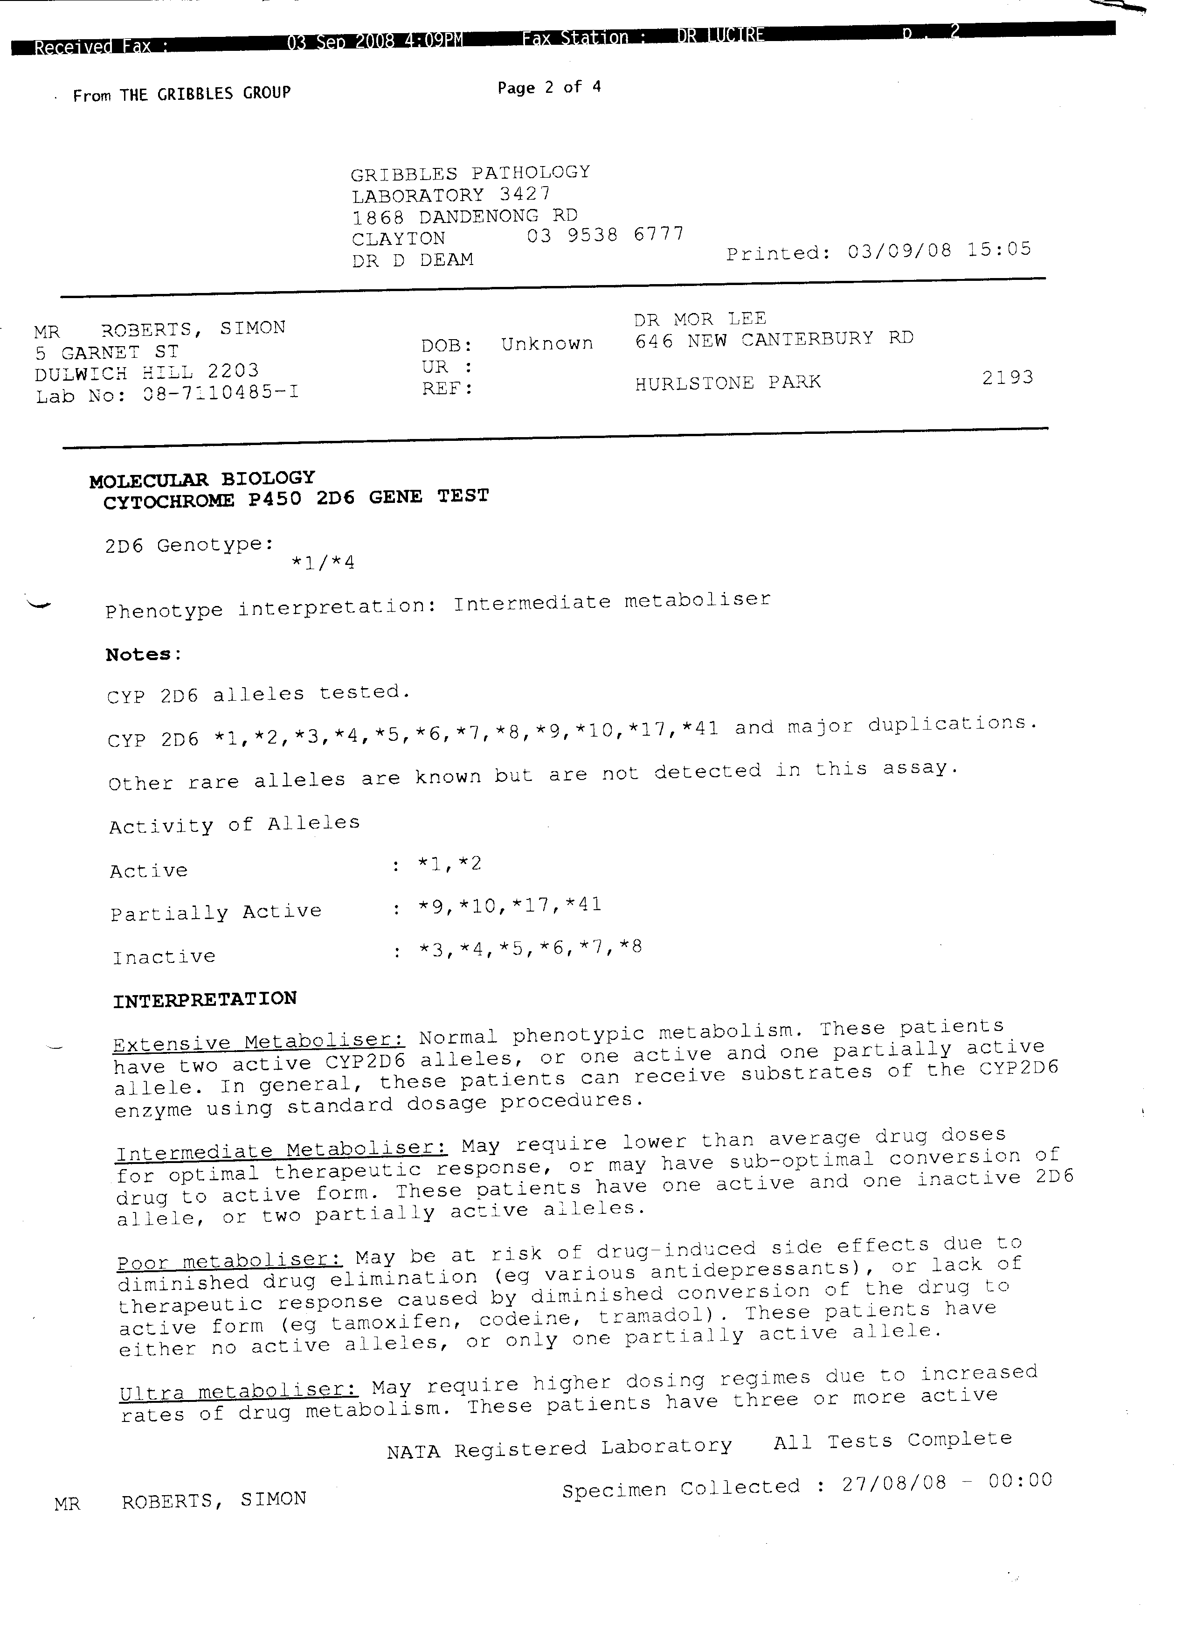
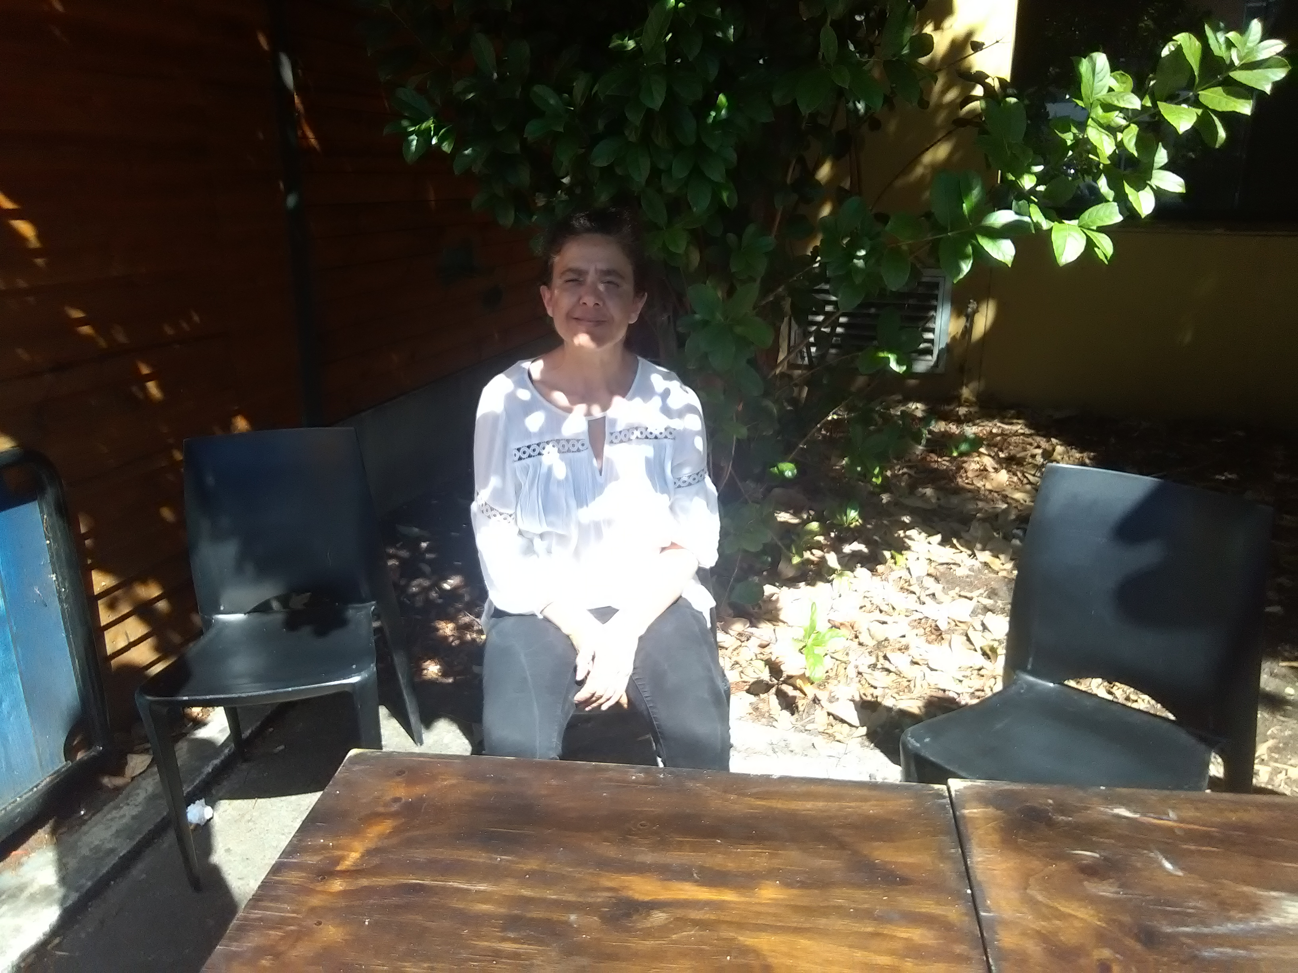
Elpiniki Iosif (Dr. Antony Roberts ~ Wife)
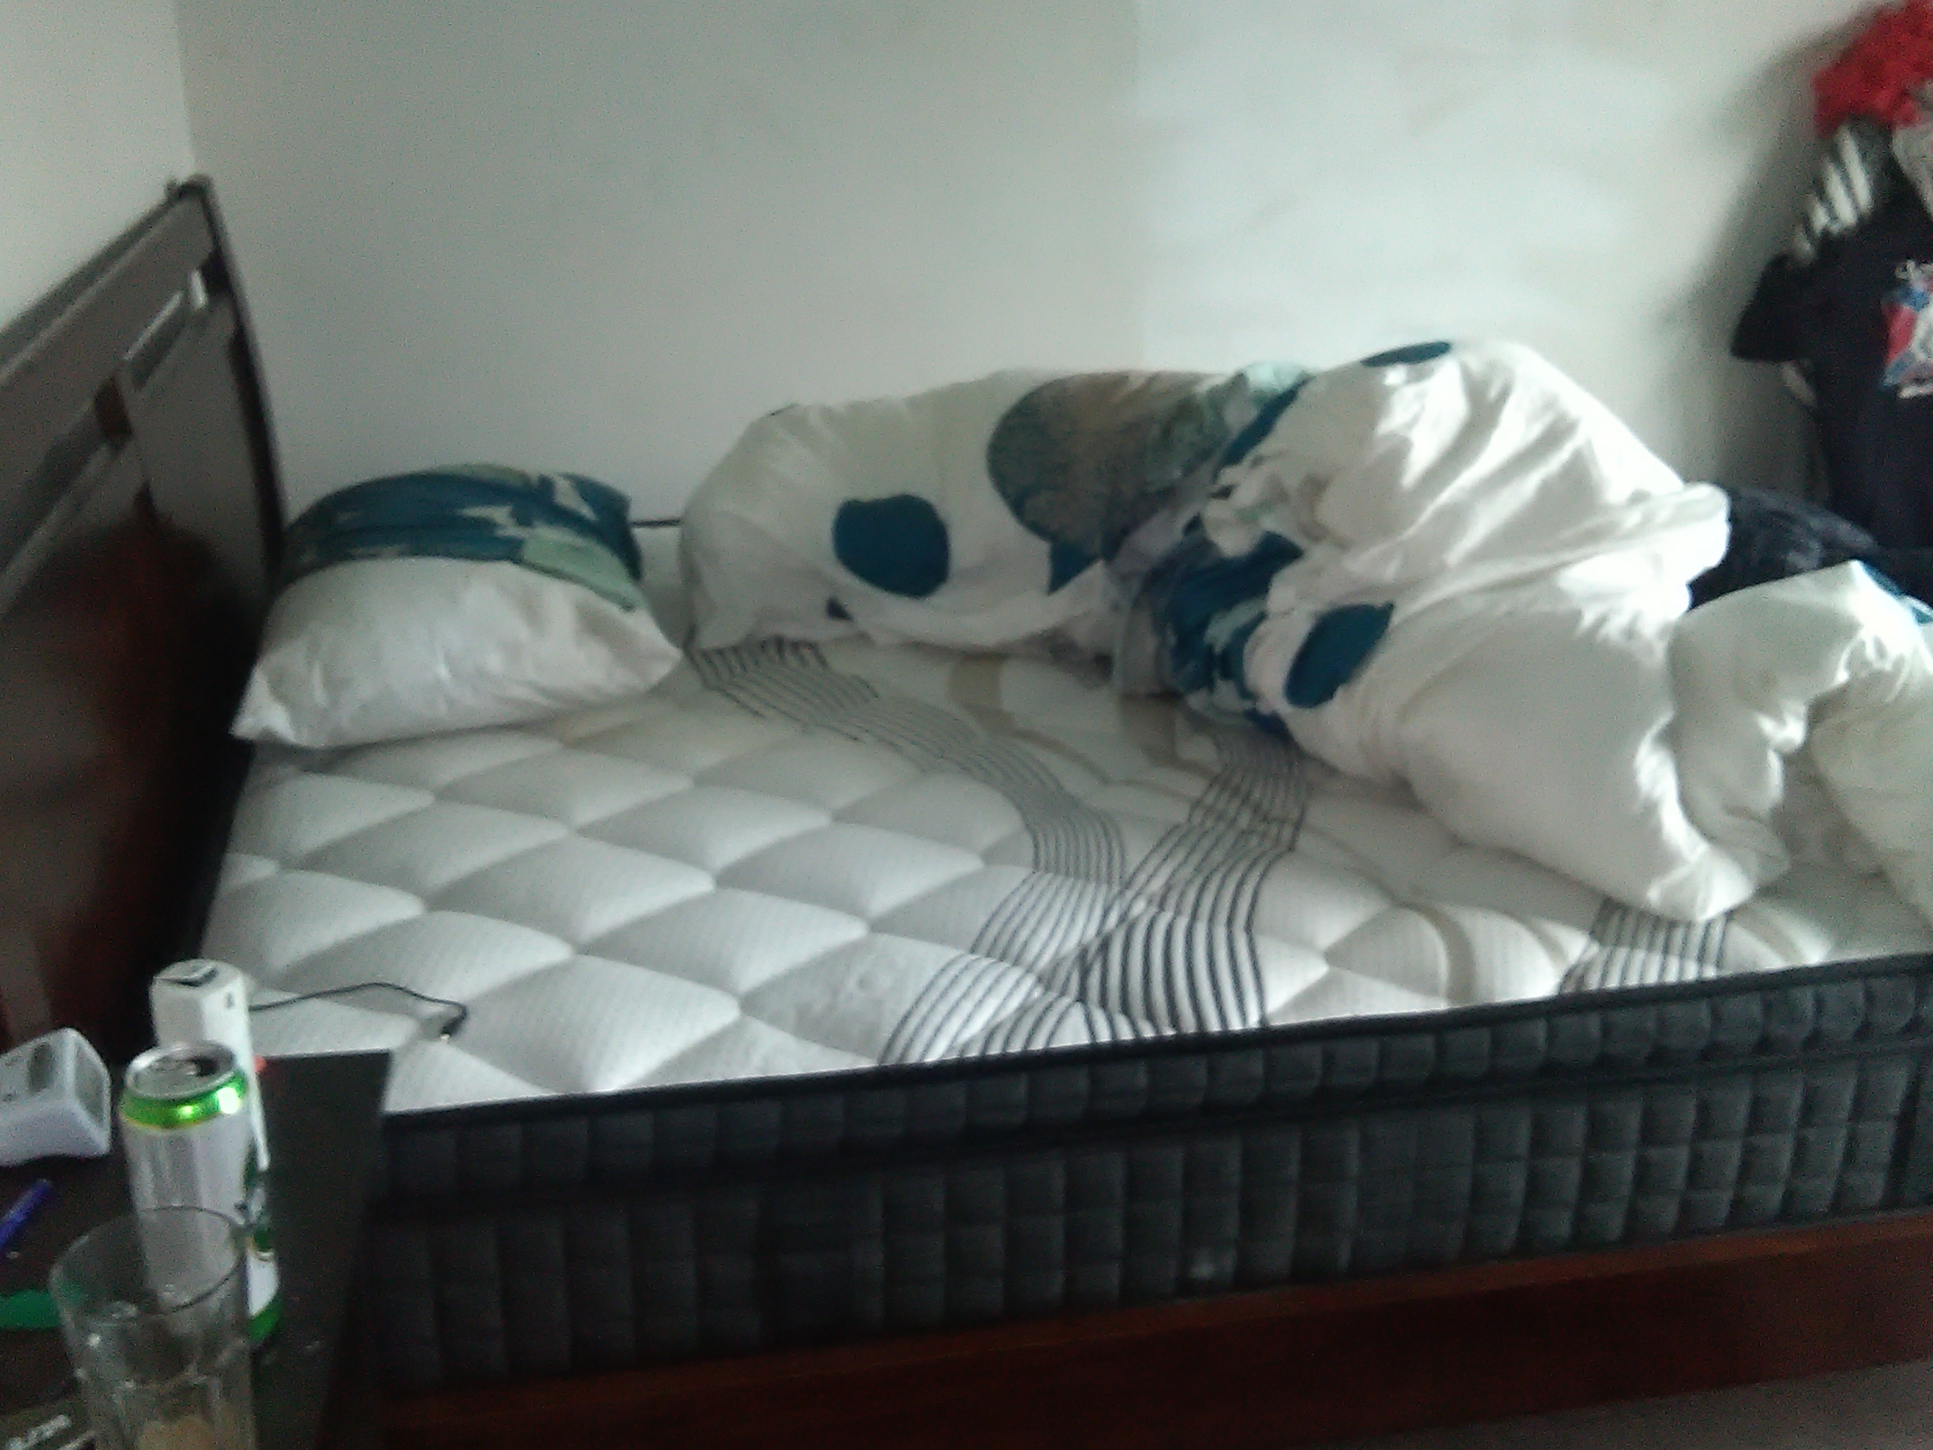
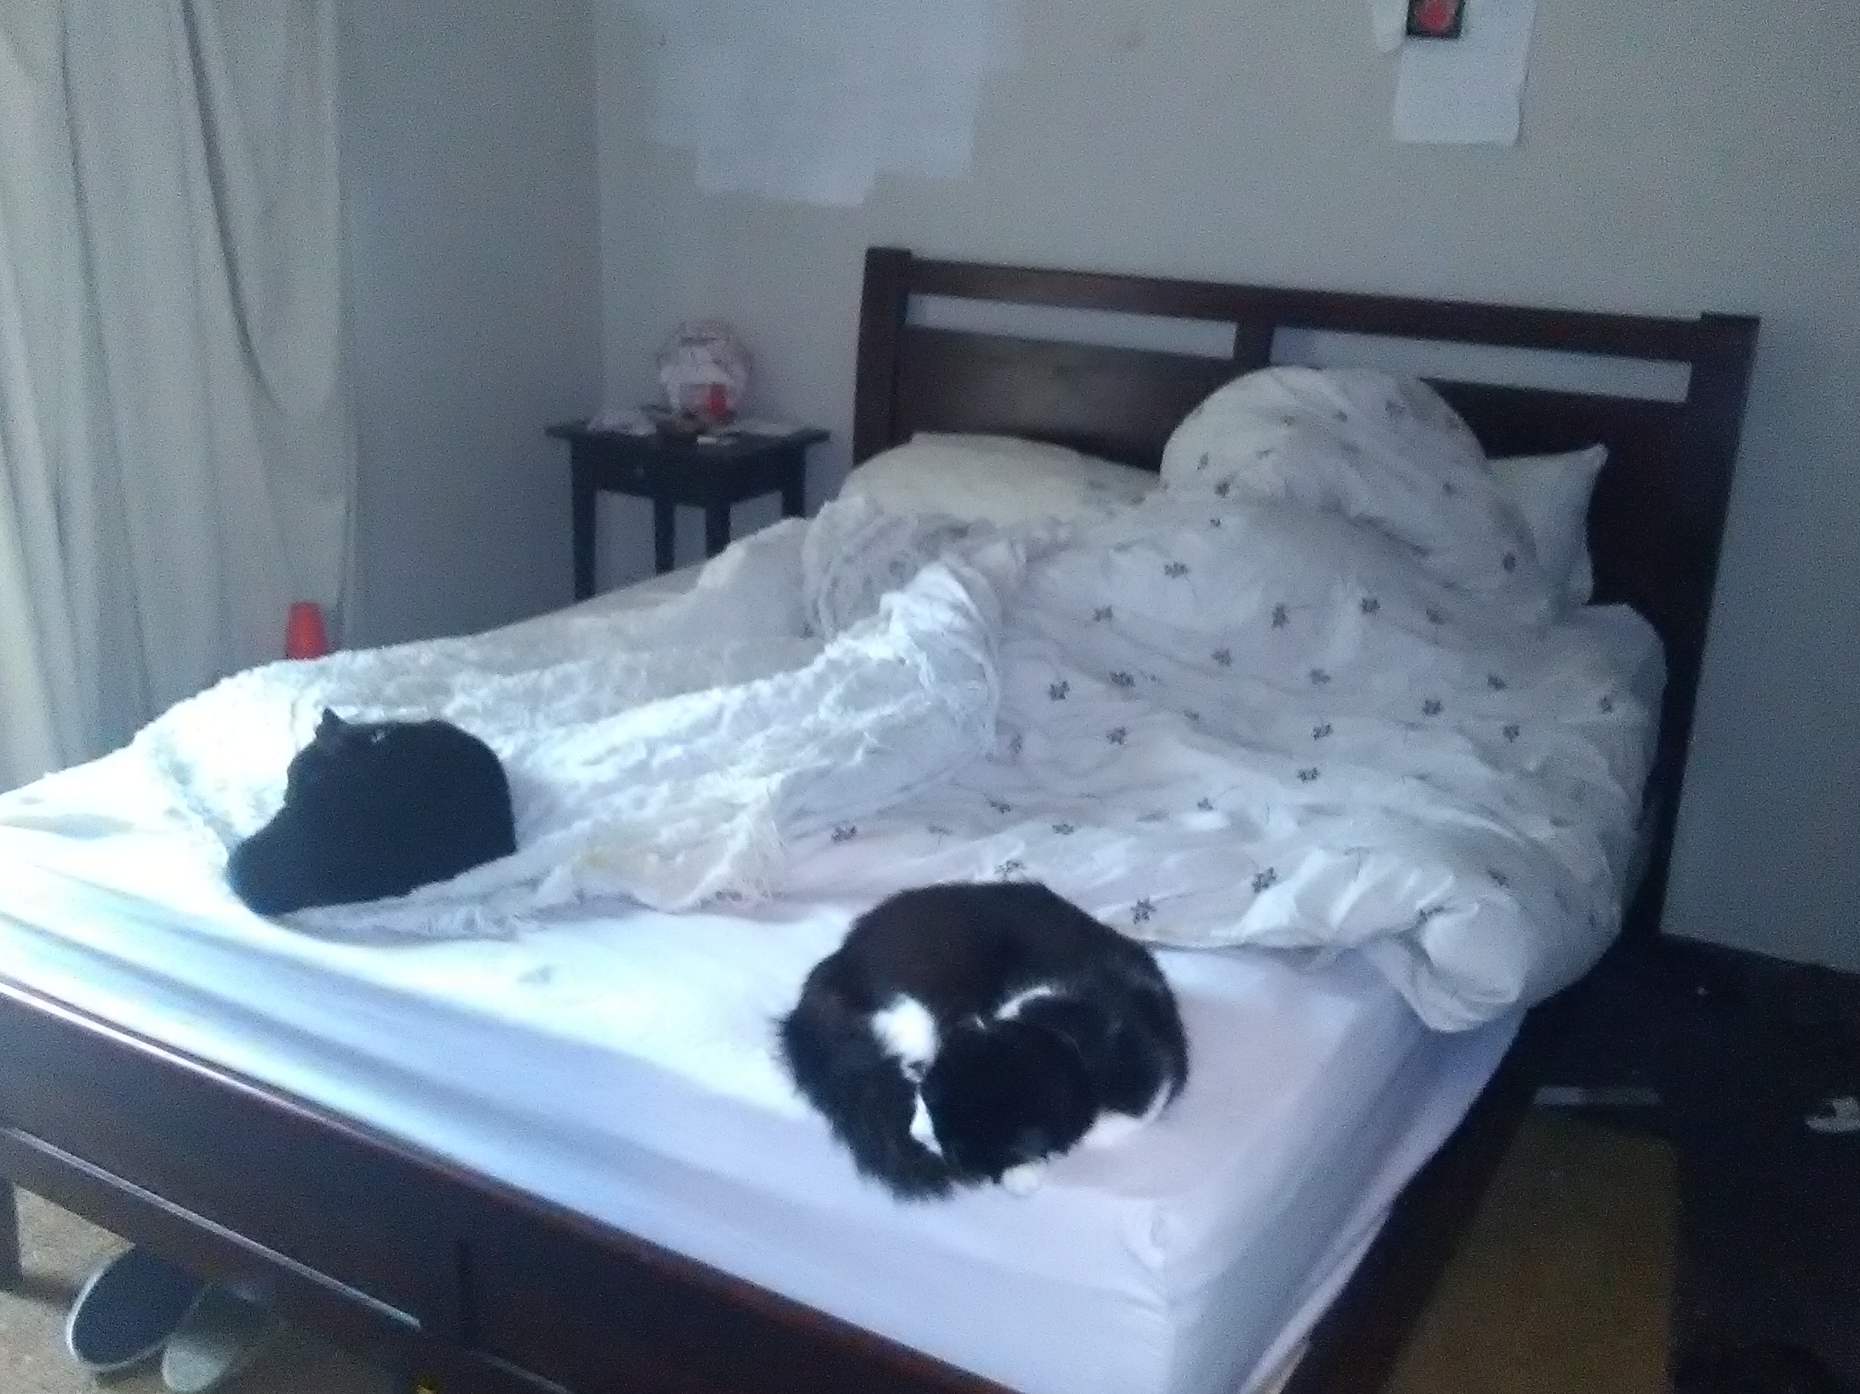
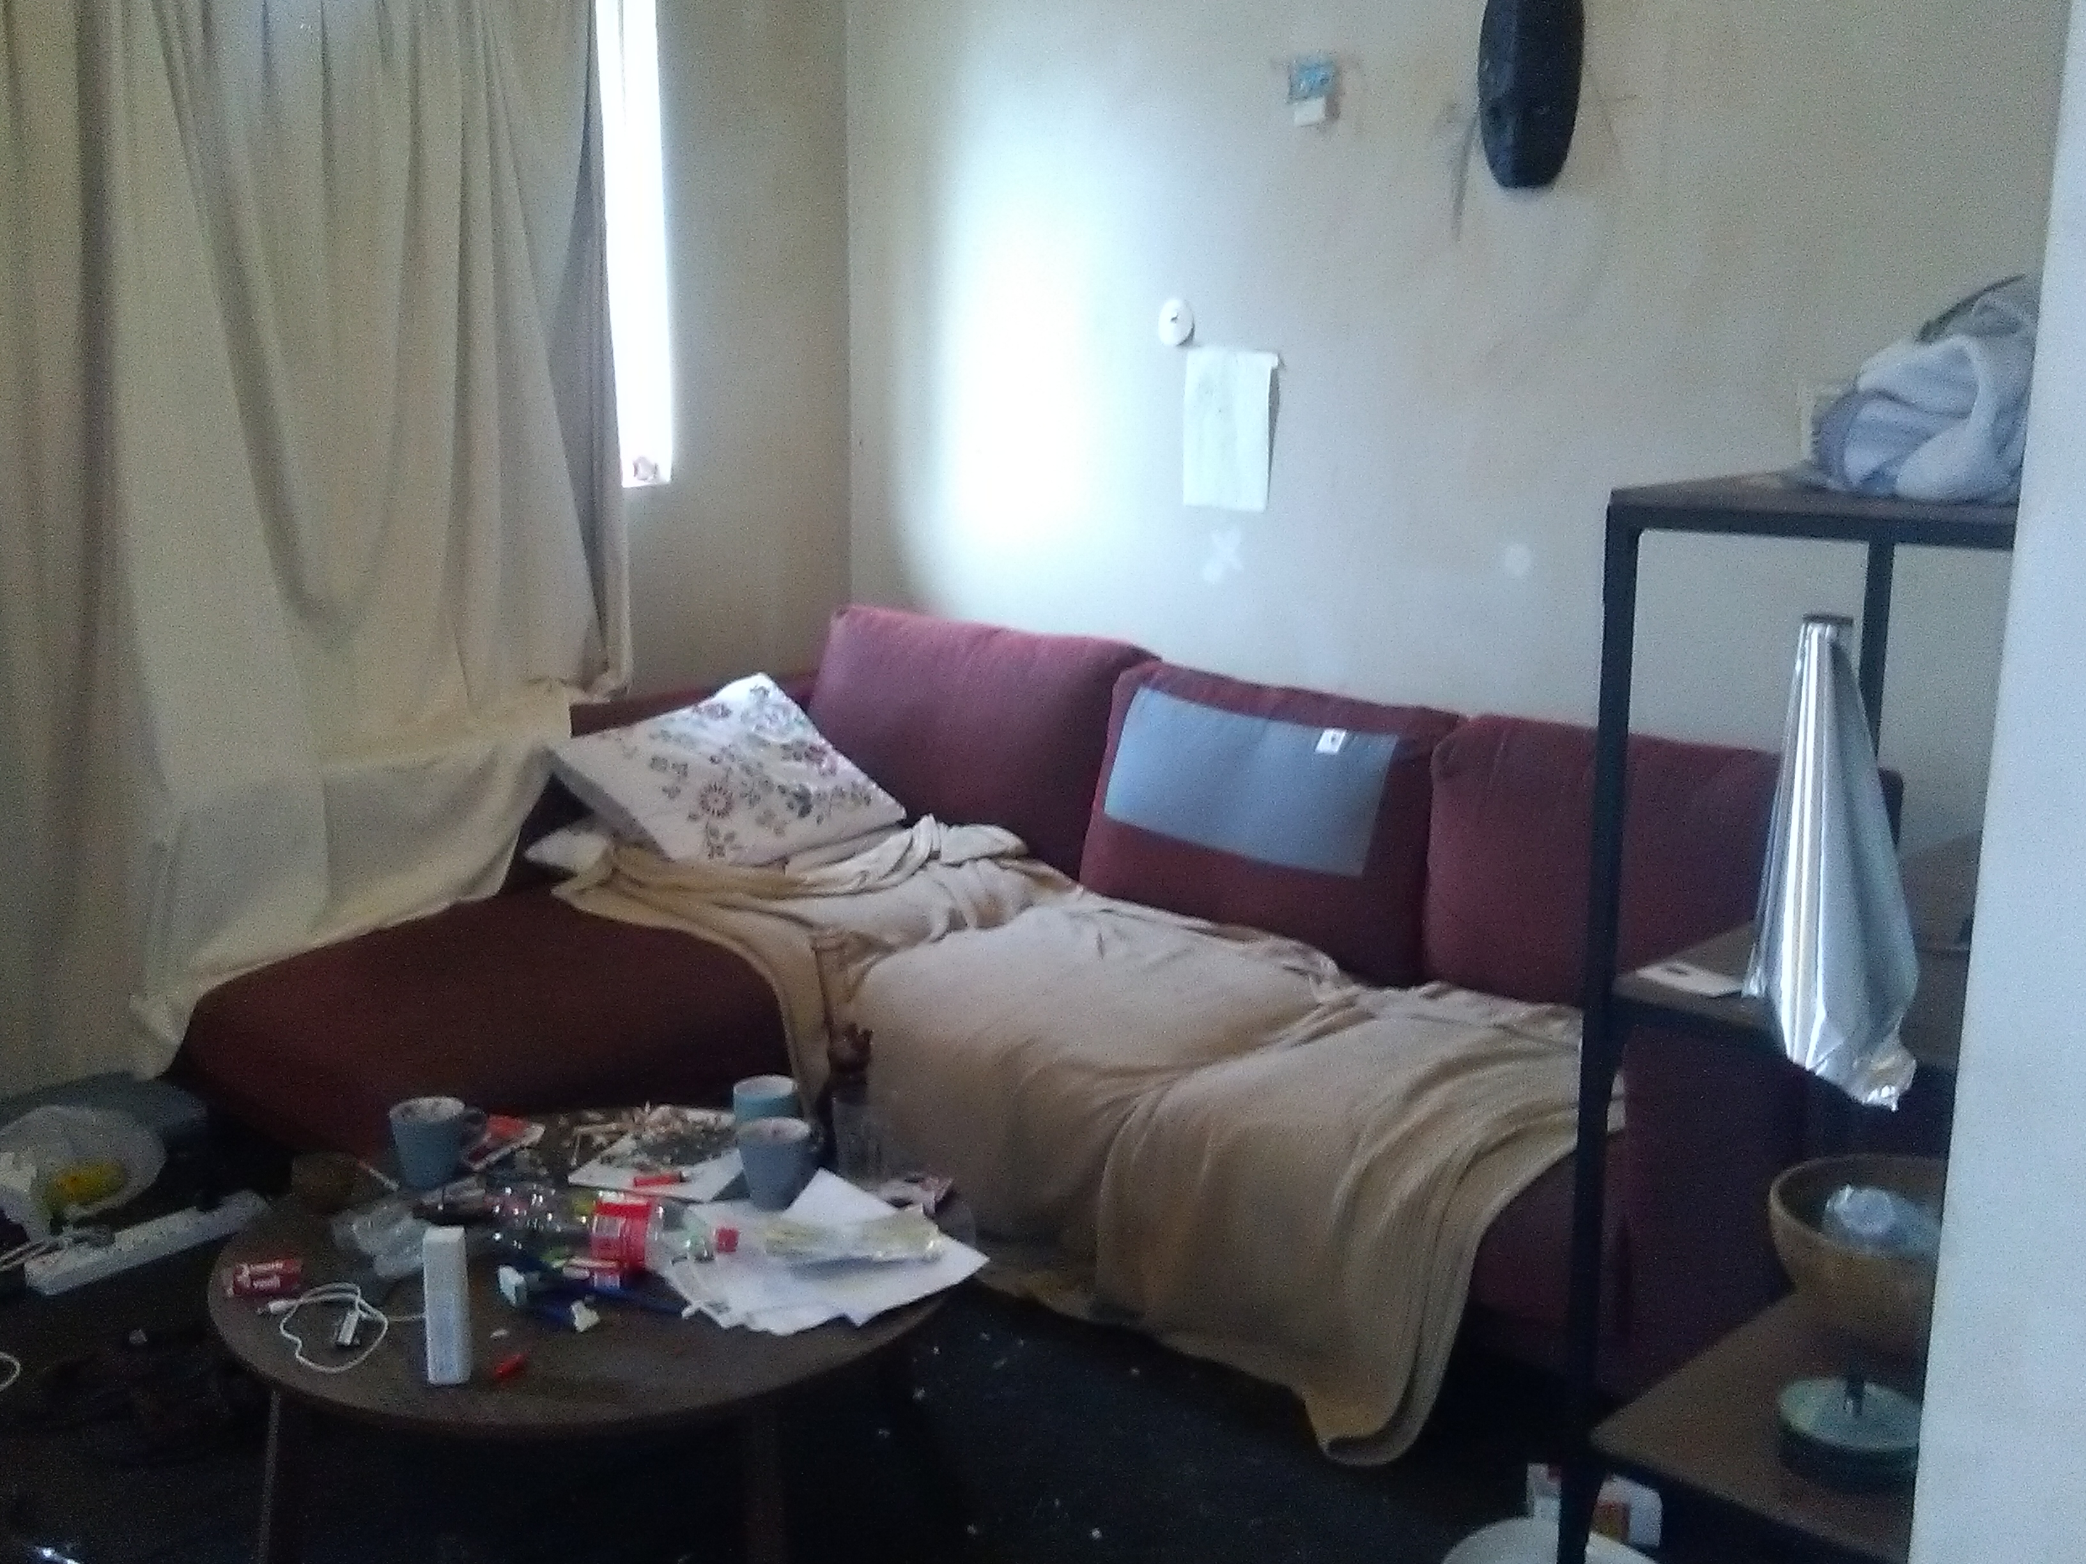
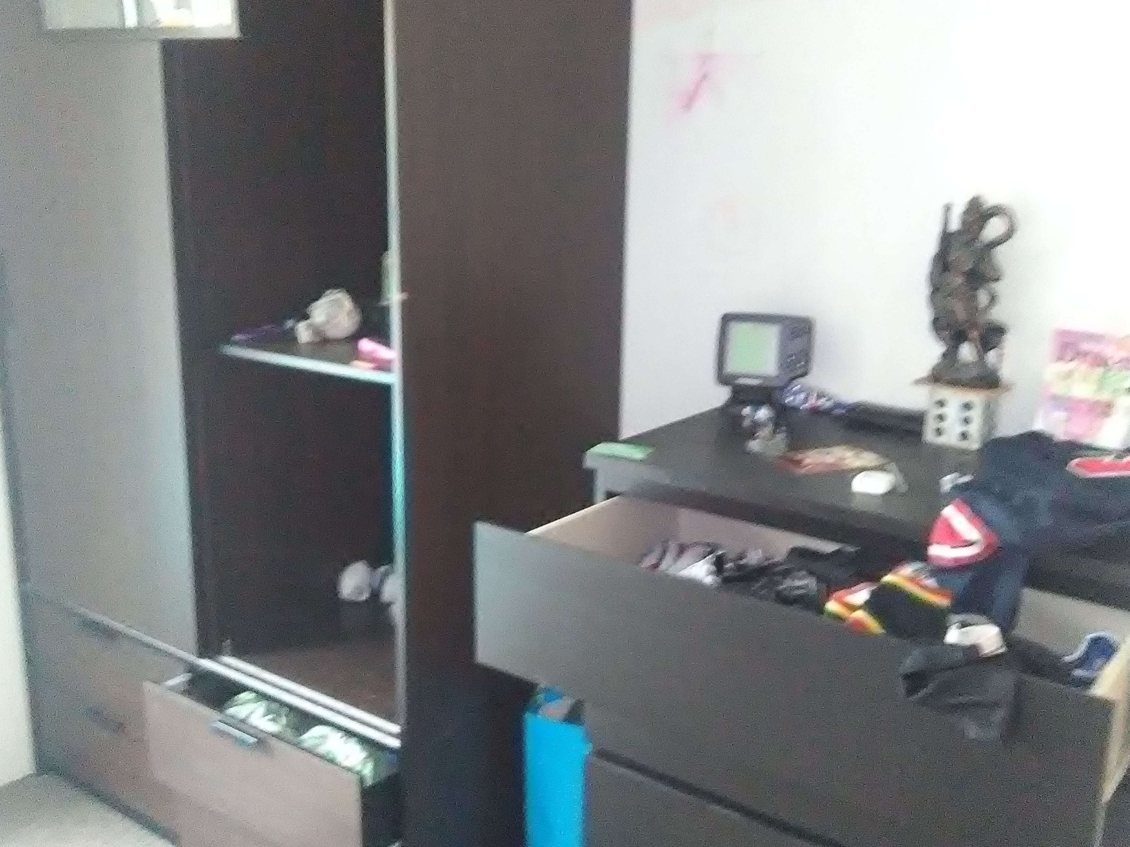
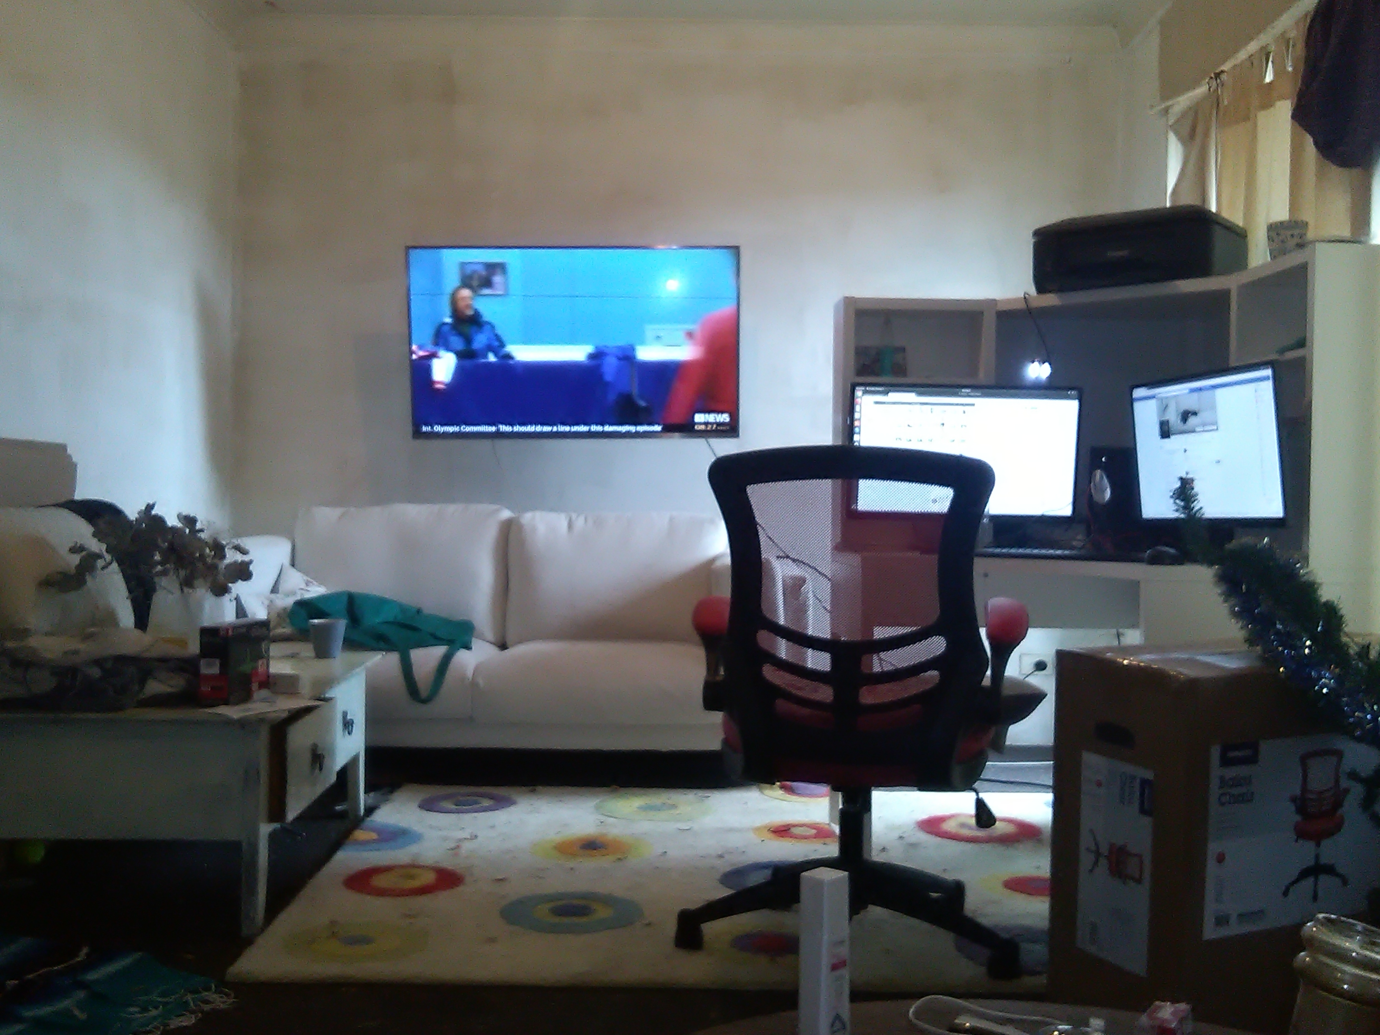
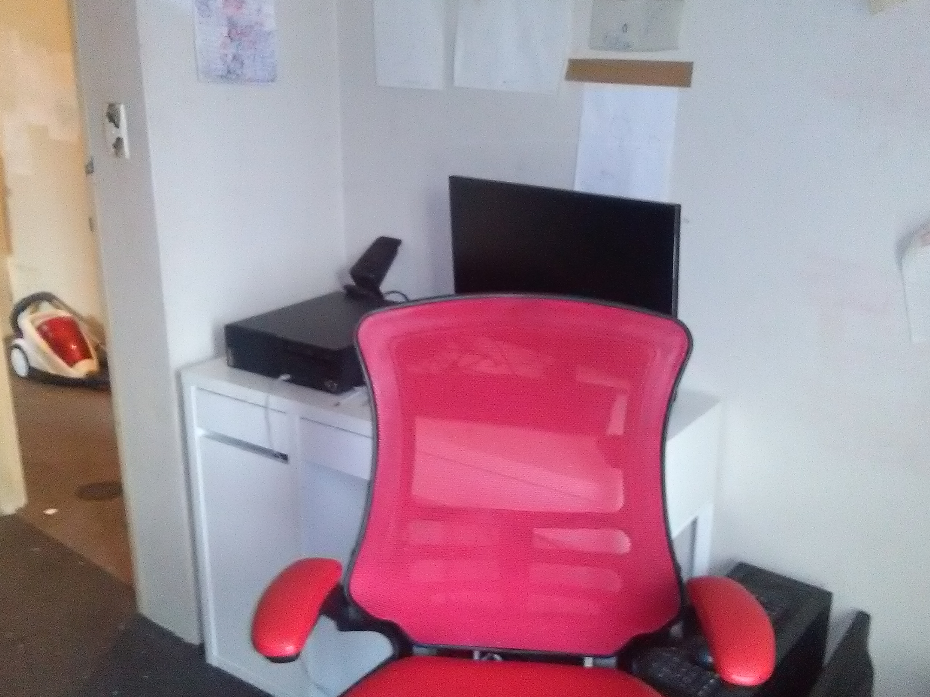
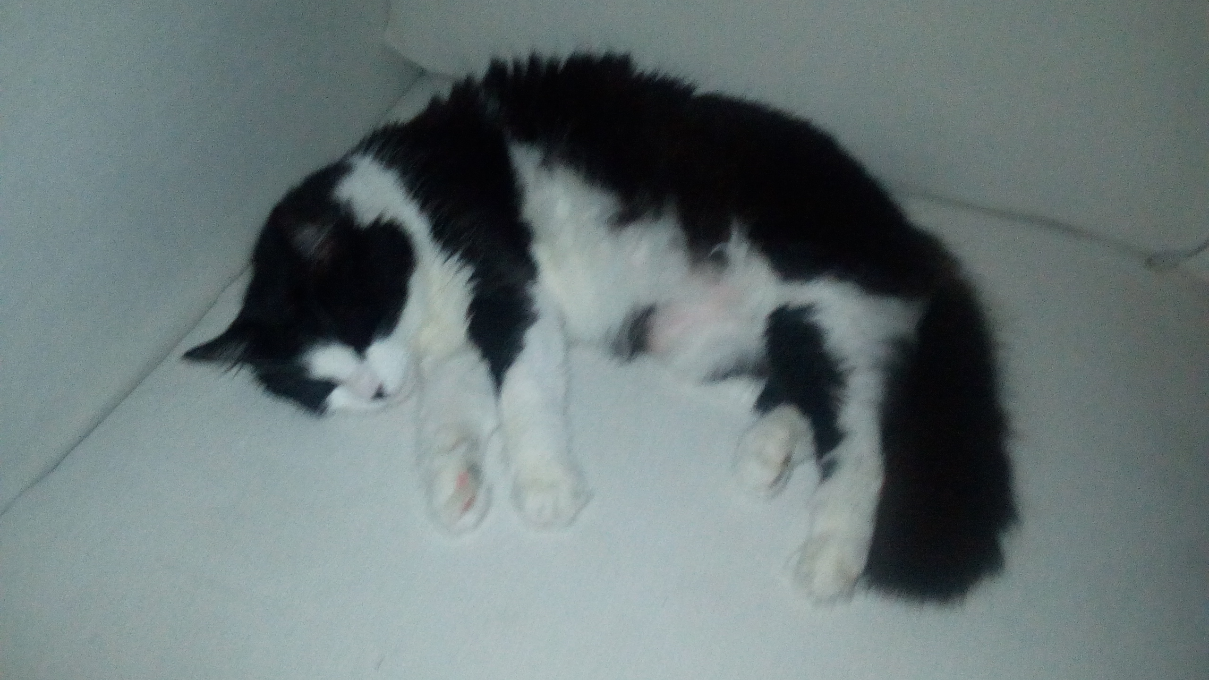
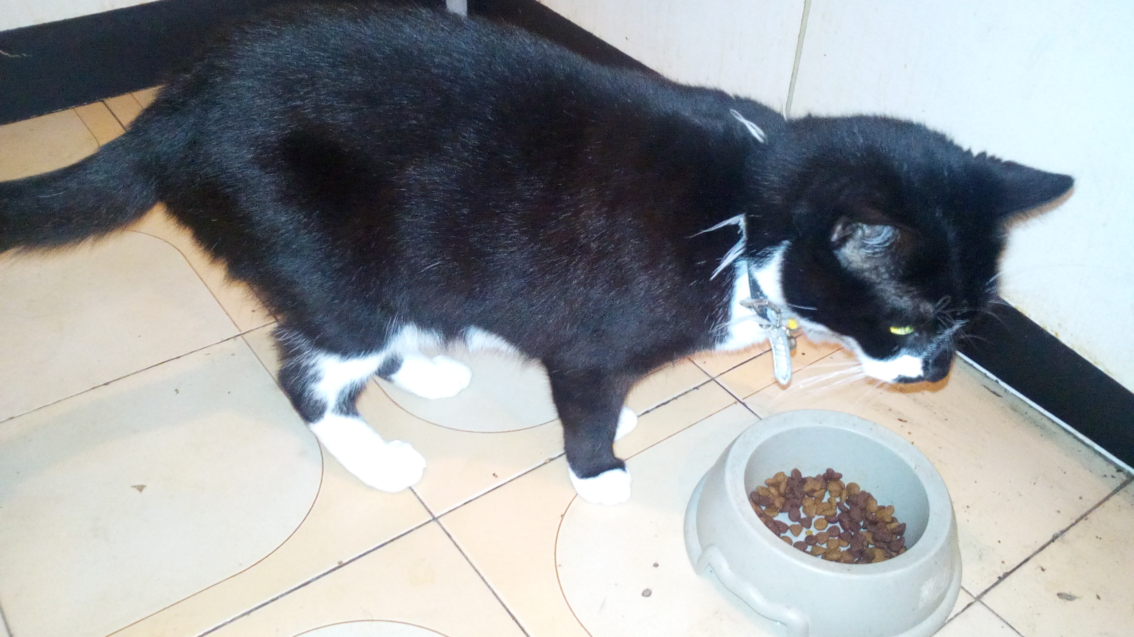
Meow Meow Twerp

Vincent Mozzerella Twerp

